House Price Prediction using Linear Regression

Dataset:
import kagglehub

# Download latest version
path = kagglehub.dataset_download ("yasserh/housing-prices-dataset")

print ("Path to dataset files:", path)

Modules

Module 1: Data Collection
import pandas as pd
import numpy as np
import matplotlib.pyplot as plt
import seaborn as sns
from sklearn.linear_model import LinearRegression
from sklearn.model_selection import train_test_split
from sklearn.metrics import mean_squared_error,r2_score,mean_absolute_error

df=pd.read_csv("/kaggle/input/housing-prices-dataset/Housing.csv")
print(df.head(5))

Module 2: Data Preprocessing
Handling missing values:
df.isnull().sum()
df.describe()
df.shape
Feature selection:
from itertools import dropwhile
x=df[['area','bedrooms','bathrooms','stories','parking']]
y=df['price']
x=pd.get_dummies(x, drop_first=True)

Train-test split:
x_train,x_test,y_train,y_test=train_test_split(x,y,test_size=0.2,random_state=42)

Module 3: Model Training

Train linear regression model:

model=LinearRegression()
model.fit(x_train,y_train)

Module 4: Prediction
Predict house prices:
y_predict=model.predict(x_test)

Module 5: Evaluation
Evaluate using: MAE MSE R2 Score
print(“mean squared error is :”,mean_squared_error(y_test,y_predict))
print(“mean_absolute_error is :”, mean_absolute_error(y_test,y_predict))
print(“R2 score is : “,r2_score(y_test,y_predict))
print(np.sqrt(mean_squared_error(y_test,y_predict)))

Regression Line
plt.figure(figsize=(8,6))
sns.scatterplot(x=df['area'], y=df['price'], alpha=0.6, label="Actual")
sns.lineplot(x=df['area'], y=model.predict(pd.get_dummies(df[['area','bedrooms','bathrooms','stories','parking']], drop_first=True)),
color='red', label="Regression Line")
plt.xlabel("Area")
plt.ylabel("Price")
plt.title("Housing Price Prediction")
plt.legend()
plt.show()

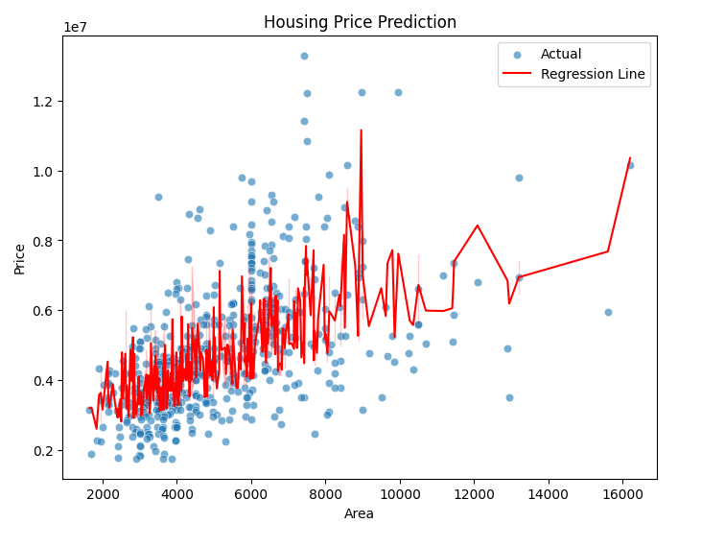

Viva Questions:
Q) What is regression?
Ans) Regression is a statistical method used to understand and quantify the relationship between a dependent variable and one or more independent variables. It helps in prediction, trend analysis, and identifying how changes in inputs affect outputs.

Q) Difference between regression and classification?
Ans) Regression is about predicting a number. It answers questions like “How much?” or “What value?”. Ex: predicting the price of a house based on its area, bedrooms, and location. The output is continuous, it could be any number within a range.
Classification is about predicting a category. It answers questions like “Which type?” or “Yes or No?” Ex: predicting whether a house is Luxury or Affordable. The output is discrete; it belongs to a fixed set of labels.
Q) What is dependent variable?
Ans) A dependent variable is the outcome you are trying to explain or predict in an analysis. It’s called dependant because its value depends on changes in one or more other variables.
Q) What is overfitting?
Ans) Overfitting happens when a machine learning model learns the training data too closely including noise and random patterns, so it performs very well on the training set but poorly on new, unseen data. The model memorizes instead of generalizing.
Q) Explain regression line?
Ans) A regression line is the straight line that best represents the relationship between two variables in a regression analysis. It’s the line that minimizes the difference between the actual data points and the predicted values from the model.

